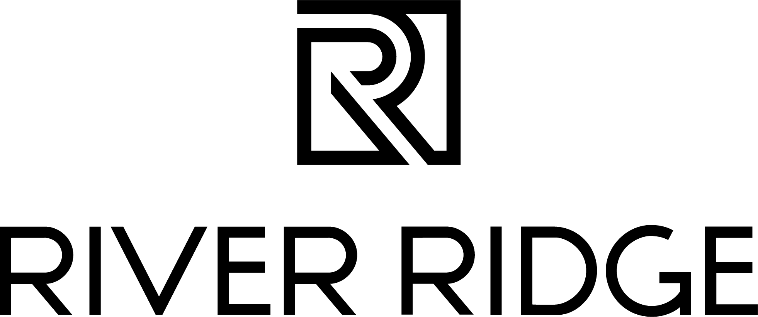
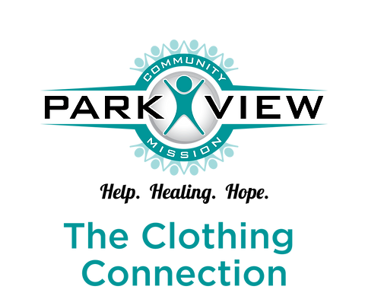

NEWS RELEASE: FOR IMMEDIATE RELEASE

August 8, 2024
Media Contact: Julia Conlon
julia@commonwealth-pr.com
804-432-7733

River Ridge and Park View Community Mission Partner for Denim Drive

LYNCHBURG, Va. — From Monday, August 12 through Tuesday, August 27, members of the Lynchburg community will have the opportunity to donate their gently used or new denim items at River Ridge for those in need, while entering to win a custom denim item from American Butt Clothing.

Donations will go to Park View Community Mission’s The Clothing Connection program, which provides clothing and small household items, free of charge, to neighbors in the community.

“We’re honored to partner with Park View Community Mission on this important initiative, especially with children heading back to school and individuals entering or re-entering the workforce,” said LJ Nadal, marketing manager at River Ridge.

One part of The Clothing Connection program is “Attire to Inspire,” which provides professional clothing and advice to individuals who are either entering or re-entering the workforce. This provides them with both professional clothing and the confidence to succeed in a professional environment.

As part of the “Attire to Inspire” initiative, The Clothing Connection is seeking denim items that could be used for work, including dark jeans or utility work pants. Other denim donations are also welcome and would be available to guests of The Clothing Connection as fashion or everyday wear.

The denim drive will accept all sizes of denim, from infants, school-aged children, to young adults and older adults.

“Just one donation can impact someone’s life in a monumental way,” said Carrie Jennings, Director of The Clothing Connection at Park View Community Mission. “As you’re taking a look through your closets and preparing for your autumn and winter wardrobes, consider donating denim that will go right back into our community for those in need.”

In addition to supporting an important cause, guests who choose to donate will be entered to win a custom denim creation from American Butt Clothing. To enter to win, guests will scan the QR code attached to the donation drop box that they utilize.

Guests who choose to donate their gently used or new denim may do so at the following River Ridge retailers:

- The Golden Honey
- Philanthropy
- KSC Boutique
- Windsor
- Zumiez
- JCPenney

###

About River Ridge
River Ridge is Lynchburg, Virginia’s premier shopping, dining and entertainment destination currently undergoing a significant redevelopment. This redevelopment has brought exciting new retail, dining and entertainment options to the property. Located off the region’s two major highways, Routes 29 and 460, River Ridge is solely owned by Liberty University and managed by JLL. For more information, visit www.shopriverridgemall.com.

About Park View Community Mission
Park View Community Mission is a 501(c)(3) nonprofit organization in Lynchburg, Virginia, with the goal of helping neighbors lift themselves out of poverty. Programs include the Food for Families pantry; Community Resource Center; Food for Thought; the Life Skills Institute; and the Clothing Connection. Today, Park View's programs continue to focus on offering help, healing, and hope, thanks to committed volunteers and supporters.

About JLL
For over 200 years, JLL (NYSE: JLL), a leading global commercial real estate and investment management company, has helped clients buy, build, occupy, manage and invest in a variety of commercial, industrial, hotel, residential and retail properties. A Fortune 500® company with annual revenue of $20.8 billion and operations in over 80 countries around the world, our more than 110,000 employees bring the power of a global platform combined with local expertise. Driven by our purpose to shape the future of real estate for a better world, we help our clients, people and communities SEE A BRIGHTER WAYSM. JLL is the brand name, and a registered trademark, of Jones Lang LaSalle Incorporated. For further information, visit jll.com.

