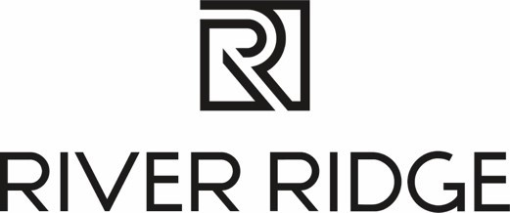

NEWS RELEASE: FOR IMMEDIATE RELEASE

March 16, 2023 Media Contact: Julia Brewster
julia@commonwealth-pr.com
(804) 432-7733

River Ridge Welcomes Newest Retailer: Ulta Beauty

LYNCHBURG, Va. — Ulta Beauty, the nation’s largest beauty retailer, is opening in River Ridge. The store will be located on the East End of the property, next to the recently added HomeGoods.

Ulta Beauty, a beauty destination with more than 1,300+ store locations across the United States, offers cosmetics, haircare, fragrances, skincare, nailcare, beauty tools and bath & body products, across all price points, along with a salon offering makeup, skin and hair services in each location.

“Ulta Beauty makes an exciting addition to the property,” said Melissa Faria, general manager at River Ridge. “With a wide variety of beauty offerings and services, there is something for everyone to enjoy at Ulta Beauty. As our River Ridge family of retailers continues to grow, we know our guests are going to love all River Ridge has to offer, including this new addition to our family. River Ridge is truly a one-stop destination for the Lynchburg area.”

The retailer is the newest addition to be announced at River Ridge during its redevelopment. Since construction began, one of the main goals of the redevelopment has been to bring diverse and differentiated national retailers, such as Ulta Beauty.

To learn more about Ulta Beauty, visit their website, Ulta.com.

# # #
About River Ridge
River Ridge is an indoor and soon-to-be-outdoor shopping destination in Lynchburg, Virginia currently undergoing a significant redevelopment. This redevelopment will bring exciting new retail, dining and entertainment options to the property. Located off the region’s two major highways, Routes 29 and 460, River Ridge is solely owned by Liberty University and managed by JLL. For more information, visit www.shopriverridgemall.com.

About JLL
JLL (NYSE: JLL) is a leading professional services firm that specializes in real estate and investment management. JLL shapes the future of real estate for a better world by using the most advanced technology to create rewarding opportunities, amazing spaces and sustainable real estate solutions for our clients, our people and our communities. JLL is a Fortune 500 company with annual revenue of $19.4 billion, operations in over 80 countries and a global workforce of more than 102,000 as of June 30, 2022. JLL is the brand name, and a registered trademark, of Jones Lang LaSalle Incorporated. For further information, visit jll.com.

