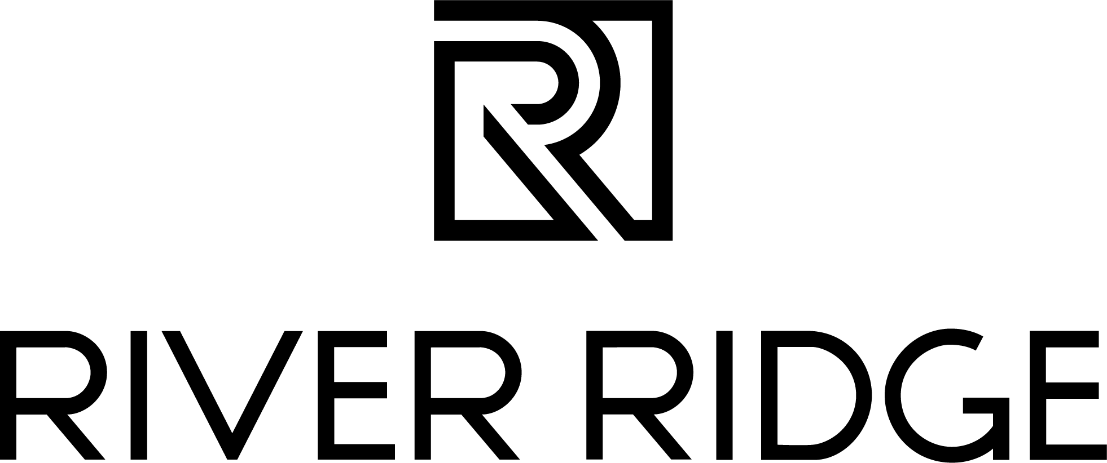

FOR IMMEDIATE RELEASE

October 4, 2023 Media Contact: Julia Brewster
julia@commonwealth-pr.com
(804) 432-7733
River Ridge and Centra Cancer Center Partner for Fifth Annual Breast Cancer Awareness Event
LYNCHBURG, Va. — On Saturday, October 7, 2023, River Ridge is partnering with the Centra Alan B. Pearson Regional Cancer Center to present the fifth annual “I Pink I Can” event for the community. This gathering is a heartfelt tribute to breast cancer survivors, an opportunity to increase awareness of breast cancer and a memorial for those who have lost their lives to the disease.
The "I Pink I Can" event will be held from 11 a.m. to 1 p.m. Within this timeframe, a special procession will occur from 12:05 p.m. to 12:30 p.m. Participants are encouraged to wear pink and join in for two laps around the interior of River Ridge. The first lap is in recognition of survivors, and the second lap is in remembrance of those who have succumbed to cancer.
“We are looking forward to bringing our community together for our fifth annual I Pink I Can event, in support of an important cause,” said Melissa Faria, general manager at River Ridge. “The Centra Alan B. Pearson Regional Cancer Center continues to make a profound impact every year, and we're honored to join forces with them and our retailers to make a difference.”
Several River Ridge retailers are joining the initiative, including SeaQuest Lynchburg, Henebry’s Jewelers, Planet Fitness, Chick-fil-A and Philanthropy. Guests are encouraged to shop at Philanthropy throughout the month, as Philanthropy will donate a portion of their October sales to the Centra Cancer Fund.
Attendees will have the opportunity to purchase Pink Ribbon Swag Bags, sponsored by WFXR, for $15 each. These bags are limited, with only 100 available for purchase. The bags include:
- A ticket for a chance to win a Garnet & Diamond Necklace in 14kt Rose Gold, valued at $739, donated by Henebry’s Jewelers
- $10 River Ridge gift card
- “I Pink I Can” event t-shirt, sponsored by Foster Fuels
- SeaQuest admit-one pass
- The chance to win a 1-year Black Card Membership to Planet Fitness
All proceeds from the swag bags, and all donations made at the event, will directly benefit the Centra Cancer Fund.
Other activities during I Pink I Can include:
- Mammogram registration, with on-site assistance provided by Centra representatives
- The Pink Ribbon Tree, which will return to the Center Court for the entire month of October, where guests can share messages of hope and encouragement
- Display tables from Centra, Live Move Be Fitness, Planet Fitness and Foster Fuels
- Pink Ribbon corn hole
- Bra pong
- Photo booth
- Refreshments, including complimentary cupcakes and water
- Purchase a pink dessert from Chick-fil-A (frosted pink lemonade and strawberry milkshake) during the event and 50% of sales will be donated to the cancer fund
“I Pink I Can is a testament to the courage and resilience of those affected by breast cancer, and we remain steadfast in our commitment to this vital cause,” Faria said.
For more information, please visit the River Ridge website.
###
About River Ridge
River Ridge is Lynchburg, Virginia’s premier shopping, dining and entertainment destination currently undergoing a significant redevelopment. This redevelopment has brought exciting new retail, dining and entertainment options to the property. Located off the region’s two major highways, Routes 29 and 460, River Ridge is solely owned by Liberty University and managed by JLL. For more information, visit www.shopriverridgemall.com.

About JLL
For over 200 years, JLL (NYSE: JLL), a leading global commercial real estate and investment management company, has helped clients buy, build, occupy, manage and invest in a variety of commercial, industrial, hotel, residential and retail properties. A Fortune 500 company with annual revenue of $20.9 billion and operations in over 80 countries around the world, our more than 103,000 employees bring the power of a global platform combined with local expertise. Driven by our purpose to shape the future of real estate for a better world, we help our clients, people and communities SEE A BRIGHTER WAYSM. JLL is the brand name, and a registered trademark, of Jones Lang LaSalle Incorporated. For further information, visit jll.com.

