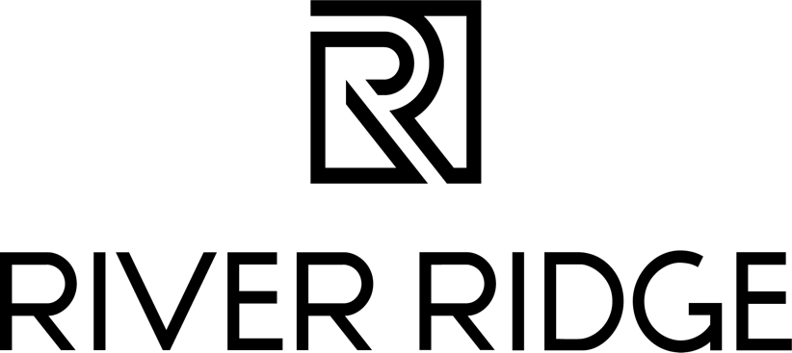

NEWS RELEASE: FOR IMMEDIATE RELEASE

May 4, 2023

River Ridge to Host Cinco de Mayo Celebration
LYNCHBURG, Va. — River Ridge is thrilled to host its first-ever Cinco de Mayocelebration: an outdoor, family-friendly festival by the West End District patio on the property by the Papa Gallo Cocina Mexicana patio. The free event is on Saturday, May 6th, from 11 AM to 2 PM, and will feature delicious food and special activities celebrating Mexican culture.

Attendees can expect a variety of entertainment offerings including music, arts and crafts, a bounce house, and a selfie station with various props. Papa Gallo Cocina Mexicana and Duck Donuts will also provide free food samples to attendees, including mini quesadillas and cinnamon sugar churro donuts.

Both Papa Gallo Cocina Mexicana and Duck Donuts recently opened at River Ridge, in the reimagined West End.

“We are looking forward to celebrating Cinco de Mayo with the community at the West End,” said LJ Nadal, marketing manager at River Ridge. “It’s a great way to kick off spring and showcase all that River Ridge has to offer to our guests.”

For more information about the event, visit River Ridge’s Facebook page or check out their website.

###
About River Ridge
River Ridge is an indoor and soon-to-be-outdoor shopping destination in Lynchburg, Virginia currently undergoing a significant redevelopment. This redevelopment will bring exciting new retail, dining and entertainment options to the property. Located off the region’s two major highways, Routes 29 and 460, River Ridge is solely owned by Liberty University and managed by JLL. For more information, visit www.shopriverridgemall.com.

About JLL
JLL (NYSE: JLL) is a leading professional services firm that specializes in real estate and investment management. JLL shapes the future of real estate for a better world by using the most advanced technology to create rewarding opportunities, amazing spaces and sustainable real estate solutions for our clients, our people and our communities. JLL is a Fortune 500 company with annual revenue of $20.9 billion, operations in over 80 countries and a global workforce of more than 103,000 as of December 31, 2022. JLL is the brand name, and a registered trademark, of Jones Lang LaSalle Incorporated. For further information, visit jll.com.

