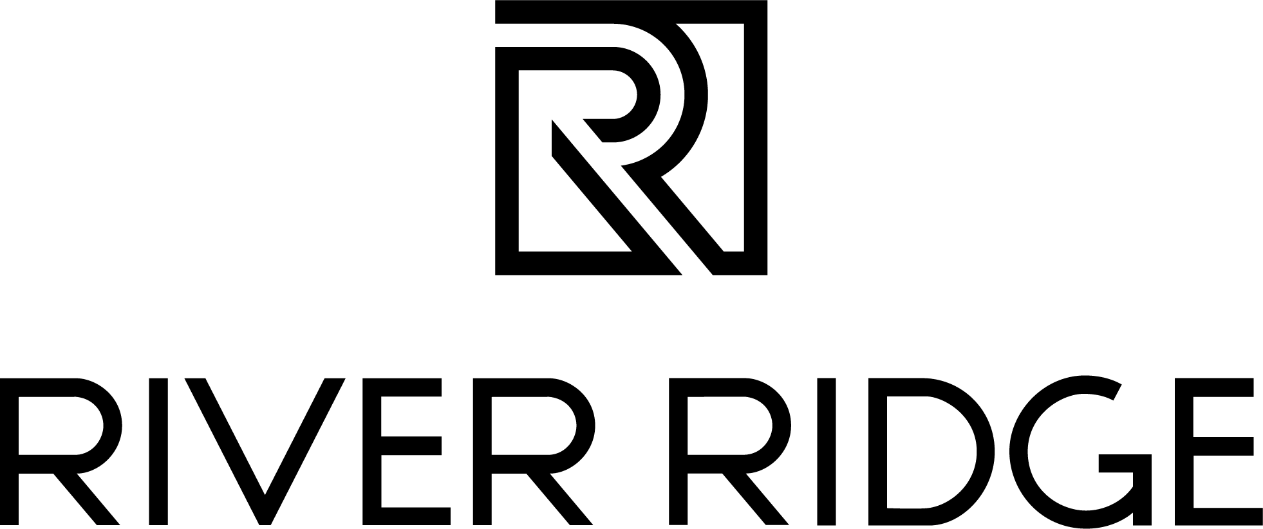

FOR IMMEDIATE RELEASE

September 11, 2023 Media Contact: Julia Brewster
julia@commonwealth-pr.com
(804) 432-7733

River Ridge: Virginia’s Largest Outdoor New Car Auto Show Coming to Property

LYNCHBURG, Va. — Virginia’s largest outdoor new car auto show is coming back to River Ridge on Friday, September 15, and Saturday, September 16. Hosted by the Liberty University Auto Club, the Liberty University Auto Show is 100 percent student-led and will feature vehicles from dealers across the area.

In April 2022, students at Liberty University hosted the club’s first-ever auto show on Liberty University’s campus, and later that October hosted their second show at River Ridge.

The event at River Ridge last fall was a huge success, according to representatives at River Ridge, with approximately 2,350 attendees over the course of the weekend. The extra space allotted by River Ridge last fall allowed the organizers to nearly double the inventory of their first event, with $11 million worth of cars and aftermarket displays featured.

This year, dealerships from across the area will once again come to showcase the latest and greatest in their inventory.

The show will take place at River Ridge’s West End from 4 – 7 p.m. on Friday, September 15, and from 11 a.m. – 7 p.m. on Saturday, September 16. The show is free to the public.

“We are looking forward to once again welcoming car enthusiasts to River Ridge and to the West End district, where guests currently can enjoy dining options such as Papa Gallo Cocina Mexicana and Duck Donuts,” said LJ Nadal, marketing manager at River Ridge.

###
About River Ridge
River Ridge is Lynchburg, Virginia’s premier shopping, dining and entertainment destination currently undergoing a significant redevelopment. This redevelopment has brought exciting new retail, dining and entertainment options to the property. Located off the region’s two major highways, Routes 29 and 460, River Ridge is solely owned by Liberty University and managed by JLL. For more information, visit www.shopriverridgemall.com.

About JLL
For over 200 years, JLL (NYSE: JLL), a leading global commercial real estate and investment management company, has helped clients buy, build, occupy, manage and invest in a variety of commercial, industrial, hotel, residential and retail properties. A Fortune 500 company with annual revenue of $20.9 billion and operations in over 80 countries around the world, our more than 103,000 employees bring the power of a global platform combined with local expertise. Driven by our purpose to shape the future of real estate for a better world, we help our clients, people and communities SEE A BRIGHTER WAYSM. JLL is the brand name, and a registered trademark, of Jones Lang LaSalle Incorporated. For further information, visit jll.com.

